**Proposal of project**

**On**

**Dhurmus Santali Foundation**

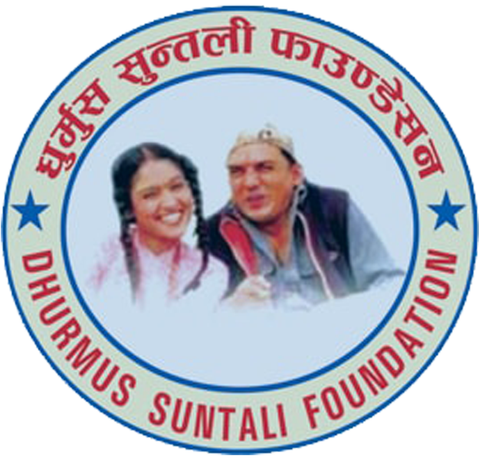

Abiraj Timalsina

00174449

Computing Project

Batch: 22 ‘B’.

Submitted to: Niman Maharjan.

Table of Contents

Chapter-1 Introduction 3

1) Project Introduction 3

2) Justification of Project 3

A. Background of Project 3

B. Problem statement 3

3) Description of the Project 4

A. Features. 4

B. Overview of the project. 4

Chapter-2 5

1. Scope of the projects 5

2. Limitation 5

3. Aims 5

4. Objectives 5

5. Overview of the scope of the projects. 5

Chapter 3 6

Development methodology 6

1. Waterfall model. 6

2. Design Pattern 7

A. MVC pattern 7

3. System Architecture. 8

Chapter 4 - **Project plan** 9

1. Work breakdown structure. 9

2. Milestones 10

Explanation of milestones. 11

3. Scheduling 12

A. Time Estimation table 12

B. Gantt chart 13

Chapter-5 14

Risk management 14

Chapter 6 16

Configuration management. 16

Chapter- 7- Conclusion 17

Chapter- 8- References: 17

# Chapter-1 Introduction

## Project Introduction

In today’s world, humanity is most important inside human being. Everyone should help each other in need on every condition with whatever they have either donating with online or with cash or by other things. Not only social worker should do these kind of stuff but if it is possible and if every single person help the needy and underprivileged people then life of those people could be quite stable for some time. Like that I also have anticipated project of Nepalese most wanted comedian actors, patriotic and people’s choice social worker “Dhurmus Suntali” project or website named “Dhurmus Suntali Foundation” where people can see their various activities and can donate as their wish.

## Justification of Project

### Background of Project

Dhurmus Suntali Charity Foundation is a social organization of two social worker, comedian actors, “Dhurmus and Suntali” founded after the massive earthquake to serve the victims. This organization is now working on human rights, child rights, early marriage, sanitation and water, against dowry system, education and so on. And also has website name Dhurmus Suntali foundation.

This website provides the major problems with justification in Nepal in different fields such as education, health, poverty raising up due to natural disaster like storm, earthquake, flood, landslides and so on in details. Moreover, user can also donate everything to foundation as their wish including money. Which will support foundation to donate for victims.

Furthermore, user can see the every projects which is divided into three different basis that is completed, running or upcoming in details. In addition, for national and international donators they have to transfer their money for donation in foundations bank details which is provided in websites home page. Recapping, if they are organizing any events then you can obviously see it day by day. And for this project I have used PHP programming language with laravel and MySQL to handle database over the web.

## Problem statement

There are a small number of problems related to donation through online. Those who provide e-banking facilities for instance eSewa, PayPal in Nepal, and to bring that facilities into Dhurmus Suntali website for direct transaction, yet that agreement has not been done. So in that case for both national and international donators they have to transfer their money through bank to foundations bank details which are provide in home page of the website. Or, they should move in office and handover the donation by cash or by cheque or anything else as their wish.

# Description of the Project

## Features.

The Features are as follows:

* **User can send the messages or feedback:** Again the user can send the messages if they want to suggest them about what they should do next or they can share their fillings how they felt from their work, and their feedback about the system features and functions.
* **User can see blogs and events:** The user can also see the blogs and events about the foundation.
* **User can see the images from the gallery:** They can also see the images from the gallery and also in different format.
* **User can visit their different social pages of Dhurmus and Suntali-**

**(Call to action buttons):** They can also visit their different social page like Facebook, twitter, YouTube which is situated at the top of the home page of the website.

* **Admin can post the blog and events:** The admin can post the blogs and events from the admin panel before that they have to log on in.
* **User friendly:** The website is totally user friendly i.e. languages are written in Nepali and in English, HCI interfaces i.e. responsive site or can be use in different size of devices and suitable color and attractive fonts and designs and features.
* **Donation detail:** The foundations bank details such as account holder name, account number with bank name is provided in the home page of the website for donators either they are national and international.
* **Search operation:** user can see the top donators from the different donators list.

## Overview of the project.

In overview, Dhurmus Suntali foundation in a social organization which is founded by the two comedian actors “Dhurmus” and “Suntali” after the massive destruction occurred in Nepal. With the intention to serve the nation and the victims they established this organization and website to display the problems with details and to ask for donation.

This website show different problems, events which are now happening in Nepal with details and as well as it provide the details of the donators who donate in need, also display the information about the different projects which divided into different parts as completed, ongoing and future projects where user can see all of these. User can see pictures from the gallery pages and can send their reviews.

But there is a small problem regarding with this website that is, in the current situation direct donation facility through this website is not available which means founders has not done agreement with those who provide online transaction services like eSewa, PayPal etc. but in this case they have to transfer money through the bank to the foundation bank details which is also provided in the home page of the website.

# Chapter-2

## Scope of the projects

The website help to store information in database such as reviews information, news and events information, do search operation, user can know who are the sponsors of this foundation etc.

### Limitation

Limitations are as follows:

In current situation directly donation facilities through this website is not available. So, donators should transfer money in the foundations bank account where the bank details of foundation are provided in home page of the foundations website or, they should move in office and handover the donation by cash or by cheque or anything else as their wish.

### Aims

The aims of this project is to reduce the social problems like dowry system, scarcity, women backwardness, human discrimination, child labor and discrimination and ripen the solid matching with government friendship, domestic societies, and associated investors to create healthy atmosphere.

### Objectives

The main objective of the Dhurmus Suntali foundation are:

* To reduce the child and adults involving in the drugs addiction by startup awareness programs
* Providing relief supplies and rescue to victims with civil people on domestic scarcity, natural disasters and so on.
* To renovate and rearrange the societies affected by the natural calamities.
* To raise voice against early marriages and dowry system and reduce the problem of the single and backward women.
* To establish different awareness programs about social problems, showbiz programs in national and international seminars and so on.

## Overview of the scope of the projects.

In overview, the foundations website help to provide the information about the social problem happening in whole over the Nepal with causes to the user with displaying solution as completed projects. The limitation of this project Is that direct donation is not available through this website so donators should transform money in the foundations bank account or they should donate either by hand to hand cash or check by moving in office. And to conclude, the aims and the objectives of this projects is to create healthy atmosphere with government friendship, domestic societies by reducing social problems like child and adults involving in drug addiction, women domination and backwardness, supplying relief material to victims and so on.

# Chapter 3

## Development methodology

Here I have used waterfall model of software development life cycle. It was the first model of life cycle developed by some software developers and it is also linear-sequential life cycle model. In this method before the next period begin, each period must be complete and this period do not overlap.

## Waterfall model.

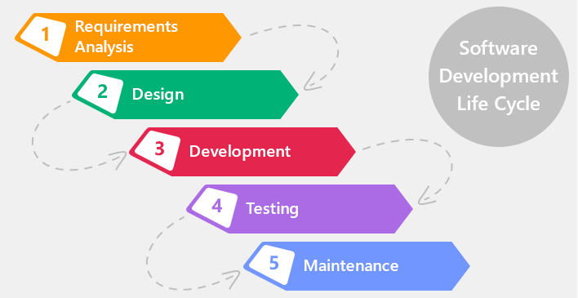

1. Fig: Waterfall model.
2. **Requirements Analysis:** In this stage all the necessities and documents of the system to be established are assembled from the clients.
3. **Design:** Then, after reviewing the necessities or requirements form the requirement analysis in this phase, the prototype of system are started to design. This design helps to define the overall system architecture and also identify the requirements of hardware and software.
4. **Development:** This stage includes small amount of coding such as coding of buttons an forms just to give the idea to client that hoe their system looks like and how their final product function. After this product is confirmed by the client then only the way to next phases is opened.
5. **Testing:** After the system in developed, it is tested by the software tester to test that the software is successfully developed according to the requirements and finally the client is involved for acceptances testing.
6. **Maintenance:** and at last, when the system is tested and deployed to the client machine then it enters to the final stage called maintenance phase. Normally, some bugs are fixed that frequently appears at this stages.

## Design Pattern

### MVC pattern

I am exhausting MVC (Model, View, and Controller) pattern while developing website. It is a pattern usually used to develop the interfaces that shares an application into three parts. It was used while developing desktop graphical user interface but now it also popular while developing websites.

Reason to for using MVC pattern is

* Model portion does not affect the view portion since it does not depend on the view portion.
* It sustenance a serial technique.
* It upkeep quick and equivalent development.

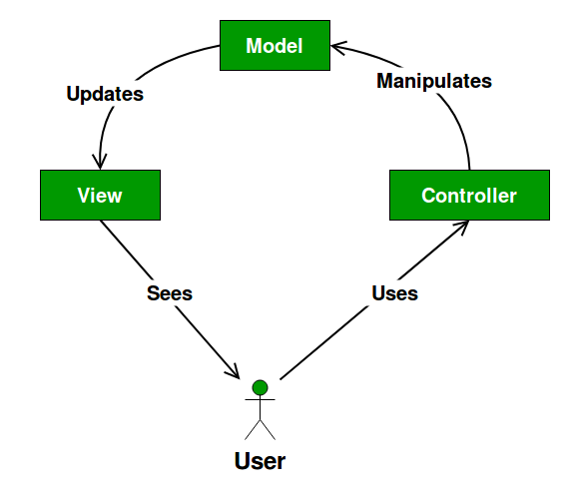

1. Fig: Model, view and Controller**.**

* **Model:** It is autonomous to the user interface and also it is the principal section of the pattern. It interact with database and connects with controller and also can occasionally update the view which depend on the framework.
* **View:** It is also called the user interface and it is what the end user sees. It usually consists of HTML and CSS and then connects with controller.
* **Controller:** It catches data from the model and send it to the view.

## System Architecture.

System architecture is the model that handles the overall structure, view and the performance of the system. Here, I have used three tier structure for the project.

Reason behind using three tier structure is because for primary facilities it enhances autonomous and then reliability. Similarly, it also increase the performance by reducing the load on the application and data tiers and then reduce the network consumption.

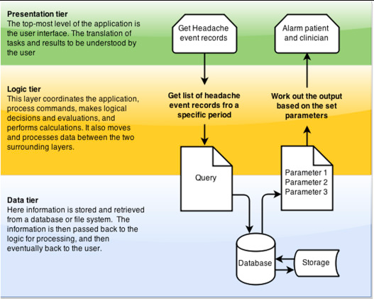

1. Fig: Tier Structure.

# Chapter 4 - **Project plan**

## Work breakdown structure.

The work breakdown structure is the deliverable-oriented that ordered breakdown of the work to be completed by the assignment team to undertake the assignment aims and generate the mandatory deliverables. Generally, work breakdown is used by project manager to execute the project.

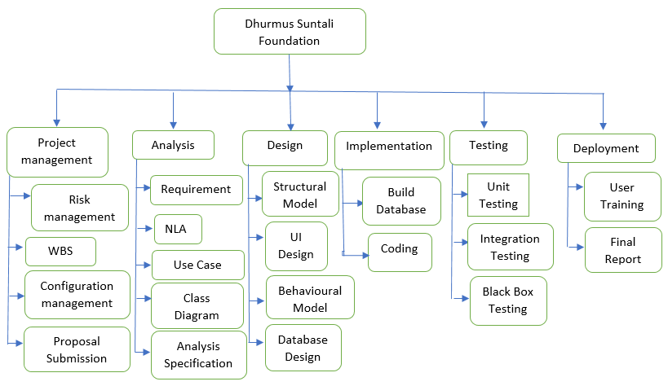

1. Fig: work breakdown structure.

## Milestones

Milestone is a contrivance applied while managing project which is used to measure the progress of a project on the way to its final objective.

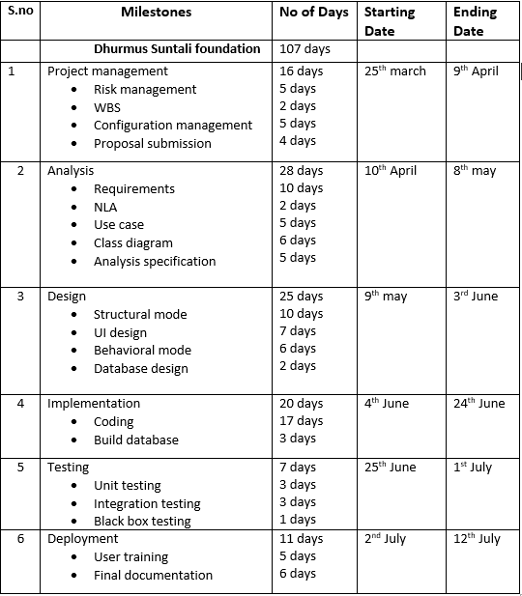

1. Fig: milestone.

## Explanation of milestones.

For each stage I have allocated different days such as for I have distributed 16 days for project management, but here in design and analysis part I have distributed quite more days i.e. 28 days for analysis and 25 days for design because this phase is confusing part and takes quite long time that other process. And for implementation 20 days, 7 days for testing and finally, 11 days for deployment which include user training and final documentation.

## Scheduling

## Time Estimation table

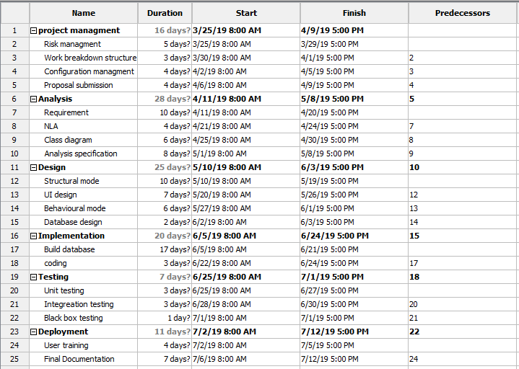

1. Fig: Time estimation table for task.

## Gantt chart

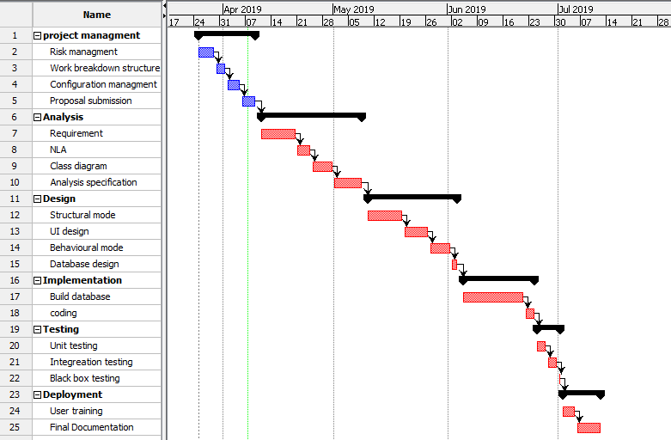

1. Fig: Gantt chart of Dhurmus Suntali foundation.

# Chapter-5 -Risk management

Risk management the process of recognizing, considering and monitoring intimidations to an administration's assets and incomes. And the below figure shows method to control risk management.

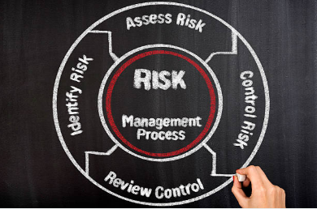

1. Fig: Risk management.

The risk likelihood with its values of this projects are shown below**.**

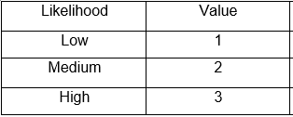

1. Fig: Risk likelihood.

The risk consequences are shown below:

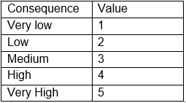

1. Fig: Risk consequences

The table of risk consequences are shown below.

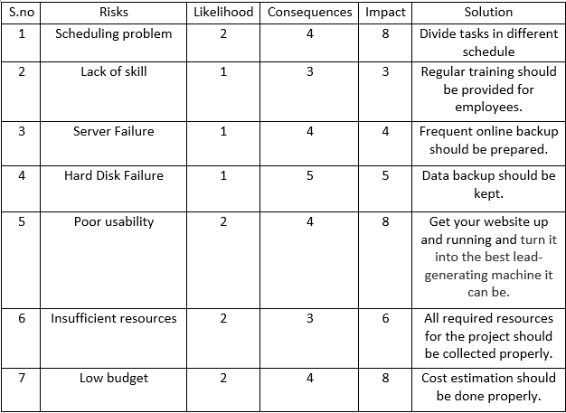

1. Fig: Table of risk consequences

# Chapter 6

## Configuration management.

It is the process of monitoring the modifications and tracing in software in relations of necessities, design, utilities and improvement of the product.

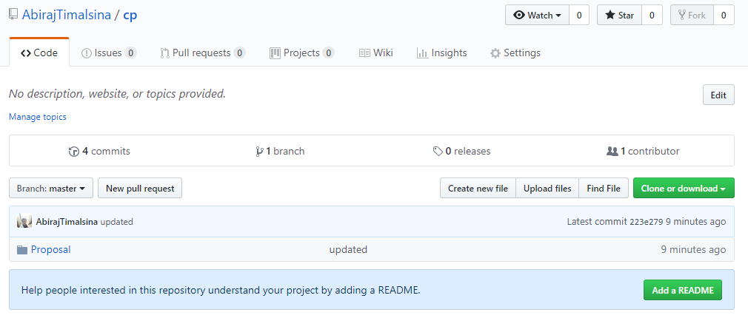

1. Fig: proposal updated on GitHub.

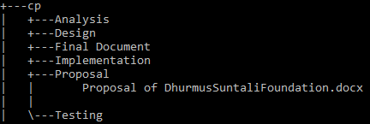

1. Fig: Tree structure of Dhurmus Suntali foundation on cmd.

# Chapter- 7- Conclusion

Dhurmus Suntali foundation in of the one of the most wanted and popular social foundation website which has features of user friendly, responsive for any kind of devices where user can see news and blogs, admin can post news and blogs, but the only one limitation Is user cannot donate directly through the foundation website for that the user have to donate their amount from bank to the foundation’s bank account where the bank details are provided in the home page, not only this user can also see the pictures from the gallery and can see the list of donators from the donators page. They not only can know the news and blogs but also can know the current problems happening in the country and then the news for help they needed.

# Chapter- 8- References:

Waterfall picture:

(2019) <https://xbsoftware.com/blog/software-development-life-cycle-waterfall-model/>

Risk management picture.

(2019) <https://www.istockphoto.com/photos/risk-management>

Tier structure:

(2019) <https://pixark.gamepedia.com/Structure_Tier>